**Assignment 4: Create VMs and Establish Connectivity**

**Objective: Create virtual machines in specific subnets and establish connectivity between them.**

create a virtual machine named "web-vm" in the "web-subnet" of the virtual network.

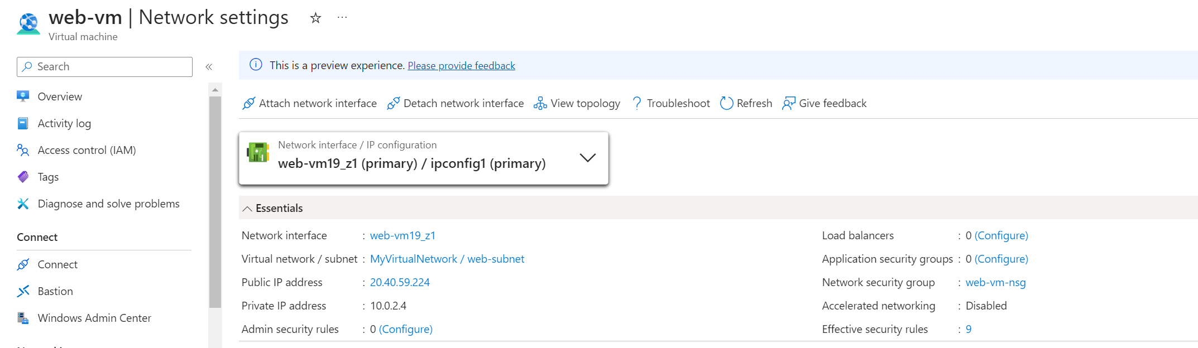

create a virtual machine named "db-vm" in the "db-subnet" of the virtual network.

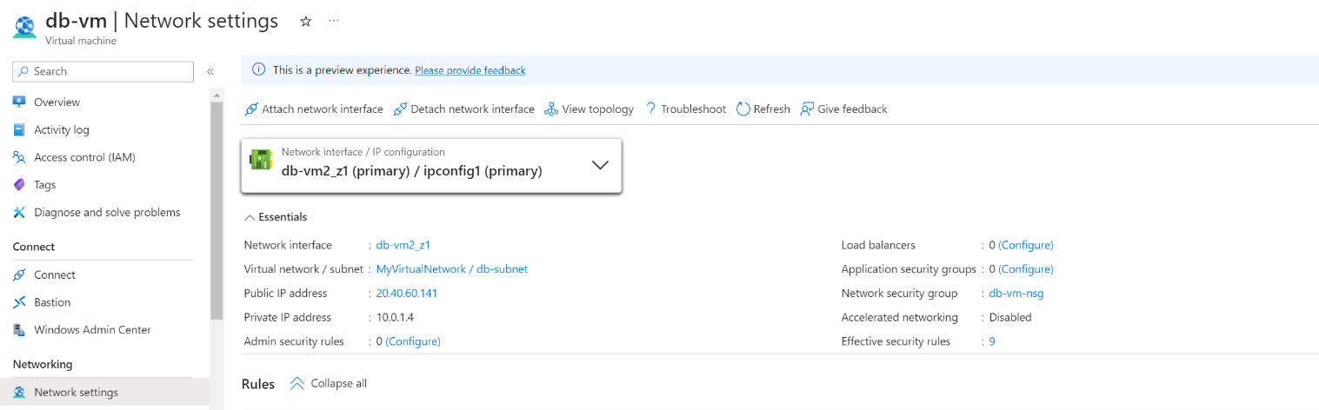

Ensure that both VMs can communicate with each other within the virtual network.

Ping from db-vm to web -vm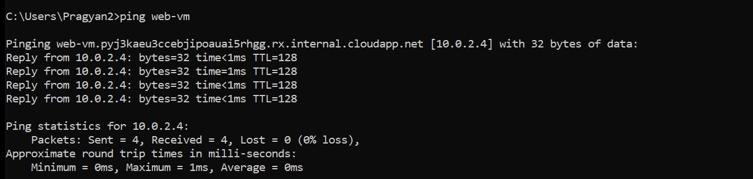

Ping from web-vm to db-vm

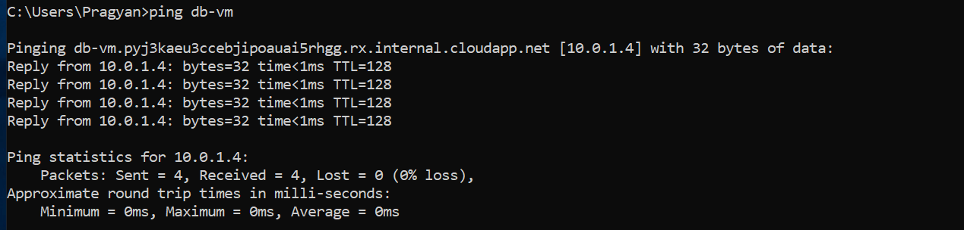

**Objective: Deploy a Windows VM with specific port redirection.**

Write a PowerShell script to deploy a Windows VM.

New-AzVm `

-ResourceGroupName 'RG01' `

-Name 'myVM' `

-Location 'East US' `

-Image 'MicrosoftWindowsServer:WindowsServer:2022-datacenter-azure-edition:latest' `

-VirtualNetworkName 'MyVirtualNetwork' `

-SubnetName 'sb1' `

-SecurityGroupName 'myNetworkSecurityGroup' `

-PublicIpAddressName 'myPublicIpAddress' `

-OpenPorts 80,3389

